Paper Template*

John Meinke, Author B

Computer and Information Sciences
University

Our Town, TX 00000
{jmeinke,author}@univ.edu

Abstract
This document describes manuscript formatting requirements for CCSC conferences. Authors can also use this document as a template to format their papers.

Length
Prepare the paper for written understanding with a length of at most ten
(10) single-spaced pages including tables, figures, and a list of references or bibliography.

Style
Write clearly and simply in the third person for an audience that is well- grounded in computing, but who may have limited exposure or knowledge about the specific topic of your paper. Define any technical terms deemed to require clarification when they are introduced.
*Copyright ©2018 by the Consortium for Computing Sciences in Colleges. Permission to copy without fee all or part of this material is granted provided that the copies are not made or distributed for direct commercial advantage, the CCSC copyright notice and the title of the publication and its date appear, and notice is given that copying is by permission of the Consortium for Computing Sciences in Colleges. To copy otherwise, or to republish, requires a fee and/or specific permission.

Title and Author Information

Please follow the example in this paper to enter title and author information. The title should use title-casing and you can use this tool to double check: https://titlecaseconverter.com
Use the following code in the “author block” if there is one author:
\author{ JohnM einke\\
C o m p uterS cienceD ep artm en t\\ A notherU n iv ersity\\ OurTown,TX00000\\
\email{jm ein k e@ u n iv.edu}
}
Use the following code in the “author block” if there are multiple authors
from different department of the same institute:
\author{
B aochu anLu\affm ark[1] ,JohnM einke\affm ark[2]\\
\affm ark[1]C om p uterandIn fo rm atio nS cien ces\\
\affm ark[2]P hysicsD ep artm en t\\ A notherU n iv ersity\\ OurTown,TX00000\\
\email{\{blu,jm einke\}@ univ.edu}
}
Use the following code in the “author block” if there are multiple authors
from different institutes:
\author{
B aochu anLu\affm ark[1] ,A uthorA\affm ark[1] ,JohnM einke\affm ark[2] , A uthorB\affm ark[2]\\
\affm ark[1]C om p uterandIn fo rm atio nS cien ces\\ S o u th w estB aptistU n iv ersity\\ Bolivar,MO65613\\
\email{\{blu,author\}@ sbuniv.edu}\\
\affm ark[2]C om p uterS cienceD ep artm en t\\ A notherU n iv ersity\\
OurTown,TX00000\\
\email{\{jmeinke,author\}@ univ.edu}
}

Body of the Manuscript
The text may be organized into sections and subsections. Please use \section and \subsection commands to define them as shown in this paper. Latex will apply section formatting rules. If you opt to number your sections and subsections, do so specifically using Arabic numbers.

Abstract
Provide a one-paragraph brief overview of the paper in both the manuscript for review and in the final manuscript for publication.

Citation
Appropriately cite all references to other published works included in the paper. biblatex is used to create a list of references or bibliography as the last section in the paper. Here are citation examples for a book[2], a journal paper[1], a website[3], and a conference proceeding paper[4].

Double Quote
The proper way to typeset double quote is to use two backticks or grave accents (`) on the left and two single quotes (´) on the right, e.g. ``Hello!´´ for “Hello!”.

Lists
Lists are easy to create in LATEX whether they are ordered, unordered, or nested as shown in the following example.
    - The individual entries are indicated with a black dot, a so-called bullet.
    - The text in the entries may be of any length.
- The labels consist of sequential numbers.
- The numbers start at 1 with every call to the enumerate environment.
- The labels consists of sequential numbers.
  - The individual entries are indicated with a black dot, a so-called bullet.
  - The text in the entries may be of any length.
- The numbers start at 1 with every call to the enumerate environment.

Math Expressions
The mass-energy equivalence is described by the famous equation

E = mc²
discovered in 1905 by Albert Einstein. In natural units (c = 1), the formula expresses the identity

E = m (1)

Tables and Figures
Include all tables and figures within the body of the text. (Provide as separate files in the original format any figures so that if there are problems with the figures coming into the final manuscript there are alternatives available to the editors.)
Here is an example Table 1.

Table 1: Nonlinear Model Results Case Method#1 Method#2 Method#3

1 | 50 | 837 | 970
2 | 47 | 877 | 230
3 | 31 | 25 | 415
4 | 35 | 144 | 2356
5 | 45 | 300 | 556
The trim size of the journal is half-letter size, so please be aware that your tables or figures may be hard to read if the fonts are too small as shown in this Figure 1.
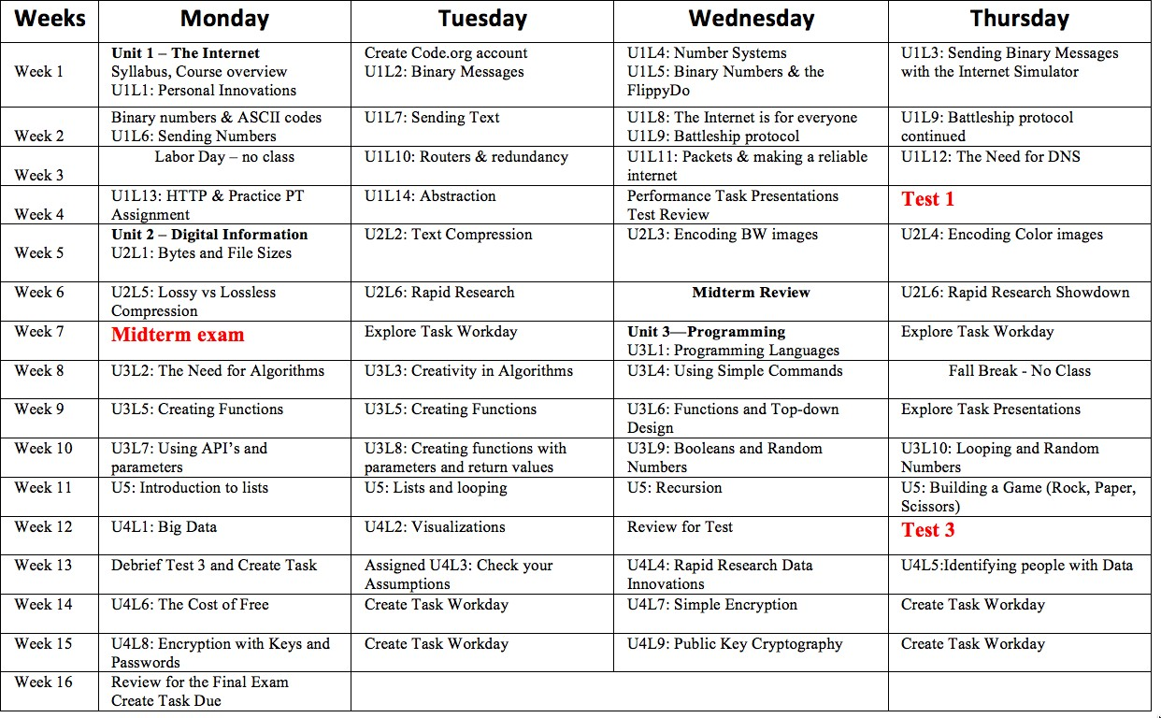

Figure 1: Fonts are too small.
In this case, you can either divide the table into multiple parts, or put the
table/figure sideways on its own page as shown in Figure 2.
The code for inserting figures sideways is as follows:
Listing 1: Code to Insert Figures Sideways
\b e g i n{s i d e w a y s f i g u r e} [H]
\i n c l u d e g r a p h i c s[width=\t e x t w i d t h] {b i g_t a b l e.png}
\c a p t i o n{Ab i gt a b l et u r n e ds i d e w a y soni t sownpage. }
\l a b e l{f i g u r e:b i g_t a b l e1}
\end{s i d e w a y s f i g u r e}

Here is a live example: https://www.overleaf.com/read/fzcmnctdppgz

Use of Color
Even though our digital journal is in color, our print journal is in black and white. You may choose to use other colors in your paper, but please be aware that the colors you choose may not be distinguishable after they are turned into gray-scale.

Reference List
The \printbibliography command prints a list of references for you. Please use sample.bib as an example to create your bibliography entries.

Code Listings
Commands from listings package allow you to display code easily with cus- tomizable coloring and styling rules. Here is an example.
Listing 2: Python example
x= 42
epsilon= 0.01 step=epsilon**2 n u m _ g u esses= 0
ans= 0.0
whileabs(ans**2 -x) >epsilonandans<x: ans=ans+step
n u m _ g u esses+= 1 ifabs(ans**2 -x) <=epsilon:
print(str(ans) +
'. is . close . to . the . square . root . of . ' + str(x))
else:
print( ' F ailed . to . find . square . root . of . ' +str(x)) print(" The . num ber . of . guesses . is ." +str(n u m _ g u esses))
6

Figure 2: A big table turned sideways on its own page.

Manuscript Submission
The following materials will need to be submitted: 1.The final manuscript in Latex.
- Copyright release. It is essential that we receive the copyright release form. By signing this form you are acknowledging that the manuscript has not been printed in another venue, plus you are retaining your rights for use of the manuscript. Read the copyright release. The Consortium will not prohibit you from using the manuscript, but will ask that you credit any reuse to the Consortium as the original source of publication. If you misplace the copyright form, a generic copyright form can be found through the Copyright Release Form[5].
The Consortium encourages multiple presentations of tutorials and work- shops. If you are presenting a tutorial or workshop you may retain the copyright, but we must have that documented. Keep in mind that your manuscript is limited to two pages total. However, you must still submit a copyright form.
Please note that it is critical that you obtain permission to use third party material. If you use diagrams and such that are attributable to a third party you must obtain formal permission to reprint such items, and must so indicate in the copyright release as well as submit such permission.
- Registration for the conference, along with the appropriate registration fee. We have found that there are some folks in need of publication for promotion and tenure purposes, and then don’t want to present the paper. A major plus of the Consortium conferences is the presentation of the papers, and you must plan on attending. If you do not present the paper at the conference the paper will be removed from the ACM Digital Library.
- A statement of any special presentation needs that you may have.
- A pdf version of your manuscript is most helpful. If there are problems with special characters or special formatting this provides the editors with what you expected your final manuscript to look like. Providing a pdf version or a hard copy helps significantly in envisioning what the author expected the final product to look like.
- Electronic copies of any graphics in a standard format (bitmap, jpeg, tiff).

Additional Information
Please feel free to email ccsc-editors@googlegroups.com for questions. This document is modified from the CCSC manuscript formatting document[6]
created by John Meinke.

References
- Albert Einstein. Zur Elektrodynamik bewegter Körper. (German) [On the electrodynamics of moving bodies]. Annalen der Physik, 322(10):891–921, 1905.
- Michel Goossens, Frank Mittelbach, and Alexander Samarin. The LATEX Companion. Addison-Wesley, Reading, Massachusetts, 1993.
- Donald Knuth. Knuth: Computers and typesetting. http://www-cs- faculty.stanford.edu/~uno/abcde.html.
- Frank Maurer. Agile methods and interaction design: Friend or foe? In Proceedings of the 1st ACM SIGCHI Symposium on Engineering Interactive Computing Systems, EICS ’09, pages 209–210, New York, NY, USA, 2009. ACM.
- John Meinke. Copyright release form. http://www.ccsc.org/wp- content/uploads/CopyrightRelease2015.pdf.
- John Meinke. Manuscript formatting. http://www.ccsc.org/wp- content/uploads/ManuscriptFormatting2015.pdf.

